

System Design Document

for

MEMEit

Version 1.3

Prepared by

Group Name: MEMEit

|  |  |  |
| --- | --- | --- |
| Ian Kieswether | 11594545 | ian.kieswether@wsu.edu |
| Logan Nelson | 11577923 | logan.nelson@wsu.edu |
| Yekaalo Habtemichael | 11585389 | y.habtemichael@wsu.edu |

|  |  |
| --- | --- |
|  |  |
| Date: | 11 Nov 2019 |
|  |  |

Revisions

| Version | Primary Author(s) | Description of Version | Date Completed |
| --- | --- | --- | --- |
| V1.3 | Ian Kieswether  Logan Nelson  Yekaalo Habtemichael | Initial Version of SDD | 11/8/19 |

# 

# Activity Diagrams

## Document Purpose

## Product Scope

The use case diagram below represents the work flow for a user uploading a MEME.

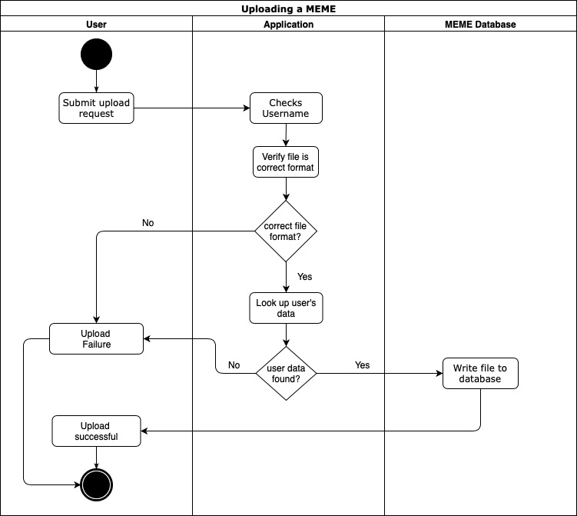

# Class Diagram

## Product Perspective

## Product Functionality

# Behavior Diagrams

## State Machine Diagram for Log In System

The diagram 3.1 is for the log in sub-system of the MEMEit system. It explains how the log in process goes from the programmers perspective.

Diagram 3.1

*Log In Sub System*

## State Machine Diagram for Content and Browsing system

The diagram 3.2 is for the content and browing sub-system of the MEMEit system. It explains how the process for browsing and adding data goes from the programmers perspective.

Diagram 3.2

*Content and Browsing Sub System*